The title of your contribution goes here
SurnameA C.¹, SurnameB D.E.², ...
¹Affiliation, Institution, City, Postcode, Country
2Affiliation, Institution, City, Postcode, Country
Please follow these guidelines to prepare your abstract:
- write your abstract in Times New Roman and use the following font sizes:
  - title – 14 pt, bold
  - Authors – 11 pt, bold
  - Body/text – 11pt,
  - Paragraphs title (References) – 11pt, bold
  - Figure caption and references – 11 pt
- Ensure the first line of each paragraph is indented.
- The total length must not exceed one page.
- Figures included in the text must have a maximum file size of 2MB.
- Figure captions must be placed outside the figure frame (see Figure 1 as an example).
- Cite references as given in the examples below.

ESPA is a biennial conference, with recent editions held in Tarragona (2024) and Vigo (2022). The conference brings together scientists from around the world to present and discuss their results on various aspects of theoretical and computational chemistry. It provides an excellent opportunity to share and explore the latest developments in the field. 2026 Edition will take place in Edificio Fonseca in Salamanca, from 30th June to 3rd July 2026.

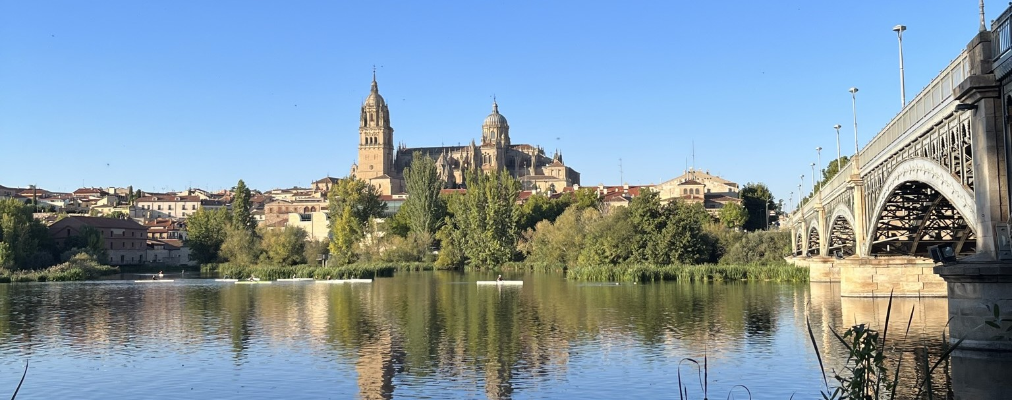

Figure 1: Times New Roman, 11 pt.

References
- SurnameA N. and SurnameB G. Journal Abbreviation 1 2 (2026)
- SurnameC F., SurnameD X.Y. and SurnameE Journal Abbreviation 3 4 (2026)

E-mail: email@domain

